



**SECTOR OF AGRICULTURE**

**MCHINJI DISTRICT COUNCIL**

**P.O. BOX 7**

**MCHINJI**



***PROGRESS REPORT HIGHLIGHTS FOR JANUARY, 2025***





**SUBMITTED TO:**

THE DISTRICT COMMISSIONER

MCHINJI DISTRICT COUNCIL

**THROUGH**

DIRECTOR OF AGRICULTURE SERVICES

MCHINJI DISTRICT COUNCIL

Contents

1.0 Introduction 3

**Financial Status (ORT)** 3

**2.1.1.2 Weather** 3

**Rainfall** 3

Generally, the district experienced wet conditions, consistent with rainy season. 3

**Temperature** 3

**Food Availability** 4

**Food Situation** 4

**Copping Mechanism** 4

**Food Availability under the Reporting Period** 4

**2.1.2.1** **Agriculture Extension Services highlights of achievement** 5

**2.1.4 Crops Development highlights of achievements** 15

**2.1.4.3 Horticulture production Achievements** 15

**2.1.4.4 Farm Mechanization Achievements** 15

**2.1.4.5 Crop protection Achievements** 15

**2.1.4.6 Crops Plans for January, 2025** 15

**3.0 Challenges** 20

**4.0 Recommendation** 20

**5.0 Conclusion** 20

# 1.0 Introduction

The sector in order to coordinate and provide guidance and direction on implementation of activities related to Agriculture it has implemented activities as highlighted below under Other Recurrent Transactions and other special programmes.

## **Financial Status (ORT)**

The directorate has an annual provision of 102,787,969 and cash flow of 12, 187,961 for July, 2023 of which 12, 187,961 had been funded representing 100% funding to cash flow.

**Highlights for Human Resources for the month of January**

1. Salary processing

2. Salary progression

3. Pensions and Retirement processing

4. Salary arrears processing

5. PSR 19 and confirmations

6. Gratuity processing

7. Disciplinary issues

**The activities shown in the diagram as follows:**

|  |  |  |  |  |
| --- | --- | --- | --- | --- |
| **NO.** | **ACTIVITY** | **PROGRESS** | **TARGET** | **REMARKS** |
| 1 | Salary processing | Done and GP5 submitted to DHRMD | All changes done | Successfully done |
| 2 | Salary progression | Continuing | All files | Partially done |
| 3 (a) | Pensions and Retirement | * Andrew C phiri (AEDO), * Clement Theu (AHSA), * James Chidzanja (Forest Guard) | All files | Submitted to DHRMD and Treasury |
| (b) |  | * Eric Sinsamala (Messenger) * Benard Banda (Ground Labourer), * Kampandira Mvula (AEDO) * Jonas Montfort (Messenger) * Andrew Phiri (Draught Animal Handler) | All files compiled | Waiting for submission to DHRMD and Treasury |
| 4 | Salary arrears | Compiled ready for processing | All files | Still waiting for resources |
| 5 | PSR 19 and confirmation letters | * Advanced ready for printing * PSR 19 and confirmation letters were written for Paswell Chiumia and Christopher Phiri (water Monitoring Assistant) | 60 percent of officers | Still waiting for resources |
| 6 | Gratuity | Dream Biscope (Forest Guard) | 1 file | Submitted to DHRMD and Treasury |
| 7 | Disciplinary issues | Daniel Chimeta (AVO) , charge |  | Waiting for feedback |

**Plans for the Month of February**

1. Salary processing

3. Pensions and Retirement processing

4. Salary arrears processing

5. PSR 19 and confirmations

6. Gratuity processing

7. Disciplinary issues, on going

**2.0 Implementation Progress / Achievements**

**2.1 Program 002 Agriculture**

**2.1.1 Introduction**

The report covers information on the progress made on Extension service delivery, major Crop and Livestock development and Soil and Water conservation activities for the month of July, 2023. The activities were conducted in all the 6 gazetted Extension Planning Areas (EPA) namely; Mkanda, Kalulu, Mikundi, Msitu, Chioshya, Mlonyeni and 5 sub-EPAs namely, Gumba, Mkanda 2, Mikundi 2, Kapiri, Nkhwazi, and Zulu which comprised of 90 sections.

## **2.1.1.2 Weather**

**Rainfall**

Generally, the district experienced wet conditions, consistent with rainy season.

**Temperature**

It had generally the district experienced a fairly typical warm to hot temperature during the period under report.

**Effects of weather on crop development**

The prevailing weather (Dry, warm to hot weather) positively affected crops by providing good germination of crops, good establishment of transplanted tobacco seedlings and reduced leaching in crop fields.

It has negatively affected crops in the sense that it Increased incidence of pest and disease attack such as FAW, especially in areas which experienced dry spells such as Kalulu where there was an infestation of Army Worm. Delayed transplanting of rice and weed growth in fields.

**2.1.1.3** **Crop situation.**

Most of the rainfed crops were harvested while in irrigaion the crop ranged from emergency to maturity.

**Food Availability**

**Food Situation**

The food situation is generally worse compared to same time last year. Out of **149,665** Farming Households, **23,672** Farming Households did not have food of their own, representing **15.8%** compared to **9,944 out** of **149,665** Farming Households representing **6.6%** same time last year (**Table 1).**

**Table 1:** Comparative Food Situation as on 28 January2025

|  |  |  |  |  |  |  |  |  |
| --- | --- | --- | --- | --- | --- | --- | --- | --- |
| **EPA** | **2024/2025** | | | | | **2023/2024** | | |
| **FHH** | **FHH without their own Food** | | | | **Total FHH** | **FHH without food** | |
| **MHH** | **FHH** | **Total** | **% Affected** | **FHH affected** | **% Affected** |
| Mkanda | 30,643 | 2,950 | 1,070 | 4,020 | 13.1% | 30643 | 1,411 | 4.6% |
| Kalulu | 16,588 | 1,244 | 2,214 | 3,458 | 20.8% | 16,588 | 670 | 4.0% |
| Mikundi | 26,497 | 1,304 | 816 | 2,120 | 8.0% | 26,497 | 1,120 | 8.0% |
| Chiosya | 14,494 | 769 | 535 | 1,304 | 9.0% | 14,494 | 1,160 | 8.0% |
| Mlonyeni | 21,264 | 1,740 | 599 | 2,339 | 11.0% | 21,264 | 2,711 | 12.7% |
| Msitu | 21,761 | 4,123 | 3,408 | 7,531 | 34.6% | 21,761 | 970 | 4.5% |
| Zulu | 18,418 | 1499 | 1,400 | 2,899 | 23.0% | 18,418 | 902 | 4.9% |
| **District** | **149,665** | **13,629** | **10,042** | **23,671** | **15.8%** | **149,665.00** | **9,944** | **6.6%** |

**Copping Mechanism**

The food insecure farming households opted for the following coping mechanisms:

* Doing petty trade to find cash for buying food items
* Dependency on remittances from friends and relatives
* Doing piece works and using the realized cash to purchase food items

**Food Availability under the Reporting Period**

Various types of foodstuffs in homesteads and local markets were readily available. Maize grain, rice grain and beans were all available with most households. Households without own food reserves were buying from different sources such as vendors and ADMARC

Maize which is a staple food for over 90% of population of the district was available and accessible by people in the district but also cassava, bananas, beans and other food sources were available and households without food were at 4%.

**2.1.2 Agriculture Extension Services**

The Extension Department has five sections of Extension Methodology, Agribusiness Management, Food and Nutrition, Agricultural Gender Roles and Extension Support Services and Communication. In the month of January, 2025, the department through these five sections conducted a number of activities despite encountering several challenges. Below are the activities that the department conducted with targets and achievements.

### **Agriculture Extension Services highlights of achievement**

During the period under report the department implemented and achieved the following activities

**DAESS Structures which are well coordinated and operational**

The period under report the district conducted 6 AASP meetings with the total participation of 113 (72m 41f)

**Program Harmonization**

The district mounted 547 harmonized demonstrations with a participation of 2938 (2106m & 832f) farmers. The demonstrations were on manure application, conservation agriculture and variety performance trails, mbeya fertilizer, double role in legumes, upland rice, potato and sweet potato. Most of these demonstrations were mounted with the support from different stakeholder in the district

**Transformation of Model villages**

During the period under report the district established 109 clusters with a total of 3252 (1704m & 1548f) farmers who are engaged in crops, livestock and fish enterprises.

The district managed to establish 28 mndandandas,

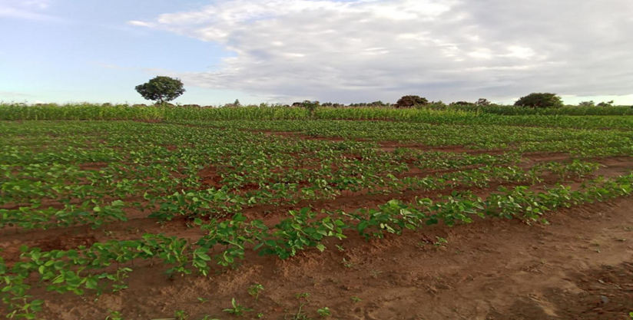

*Figure 1: Soya bean demonstration plot in Mlonyeni EPA*

Programs and projects that are gender and HIV and AIDs responsive.

The district is promoting use of labor saving technologies. Currently there are a total of 8280 (5499m &2781f) farmers that are using labor saving techniques against a target of 1620. The technologies include use of herbicides, Energy saving stoves, use of drought animals and oxen, min processing equipment.

A total of 942 (650m &242f) are implementing the household approach mainstreaming concept. The office supervised households implementing the approach. Most of the households are in the second year of their visions.

**Farmer schools established**

The district has a total of 40 Junior Farmer Field schools established. All 40 schools are mainstreaming key cross-cutting issues thus Nutrition, Gender HIV/AIDs and climate change. There are a total of 752 (407m & 345f) farmers participating in the schools. The schools are being supported by FAO.

Functional Business Oriented Farmer Based Organizations

A total of 323 (207m & 116f) farmers were trained on business management. Several concepts were covered such as business planning, marketing and market research and value addition

The office in collaboration with trade office backstopped implementation of activities in cooperatives. A total of 15 cooperatives were visited and enlightened on the new cooperative policy and improvement of cooperative governance and reporting.

**Nutrition education intensified**

The district has 1189 (836m & 353f) farmers practicing integrated homestead farming out of a target of 2200. During the period the district supervised farmers implementing integrated homestead farming in Mtanga, Kapanga, Ndeule, Chisamba and Chikulumba model villages.

A total of 44,678 (30843m, 13,835f) out of the target of 154659 farmers are practicing dietary diversification, food processing and utilization

**ACHEIVEMENTS BY OTHER PROJECTS AND PROGRAMMES**

**Transforming Agriculture Through Diversification and Entrepreneurship (TRADE)**

Conducted 1 supervision with service providers (Green Livelihoods) which are implementing TRADE activities in the district

Data collection in all 4 EPAs

**Farmers Union Of Malawi (FUM)**

Conducted ADC sensitization on YEEFA project in 8 ADCs

Conducted farmer registration exercise in Zulu and Mkanda EPA

Conducted 1 field visit to backstop demonstrations in 7 EPAs

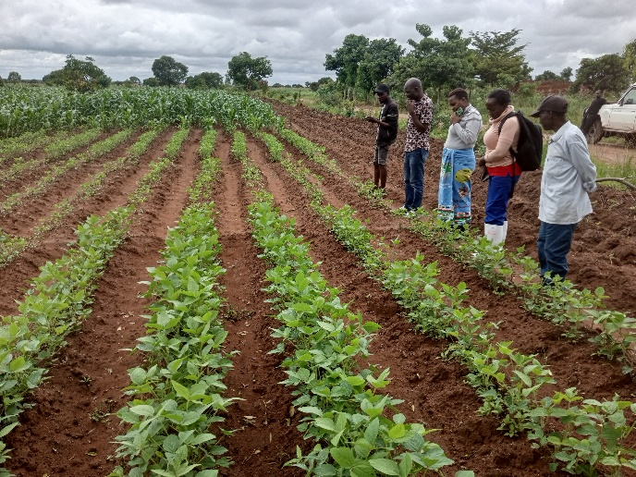 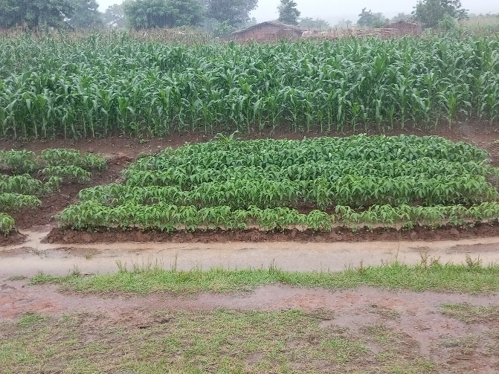

*Figure 2: Demonstration plot in Zulu EPA (left) and Demonstration plot in Msitu EPA (right)*

* + - 1. **Plans For February 2025**
  + Facilitate conduction of 24 EPA fortnightly training sessions in 12 EPAs
  + The department plans to backstop 2 fortnightly training sessions in the month in order to refresh staff on different extension concepts
  + Facilitate DASP meeting
  + Facilitate finalization of DAESS structures formation
  + Strengthen farmer groups towards market oriented production
  + Facilitate field days in various technologies
  + Facilitate preparation of District Agriculture Field Day through DAECC

#### **2.1.3 Sustainable Management of Agricultural Land**

**2.1.3.1 Soil Fertility Improvement and Agro Forestry Technologies**

**Soil Fertility Improvement Programme**

**Manure Making**

A total of 900 heaps of manure have been made during the month with the involvement of 1,107 farmers of which 510 are males and 597 are females, to date 77,225 heaps have been made with the involvement of 37,020 farmers of which 19,312 are males and 17,708 are females, out of an annual target of 84,000 heaps with the involvement of 8,400 farmers of which 4,200 are males and 4,200 are females.

**Manure Application**

A total of 948ha have been applied with various types of manure during the month with the involvement of 4,625 farmers of which 2,239 farmers are males and 2,386 are females, to date 20,676ha has been applied with various types of manure with the involvement of 67,506 farmers of which 38,159 are males and 29,347 are females, out of an annual target of 11,500 ha with the involvement of 28,750 farmers of which 14,375 are males and 14,375 are females

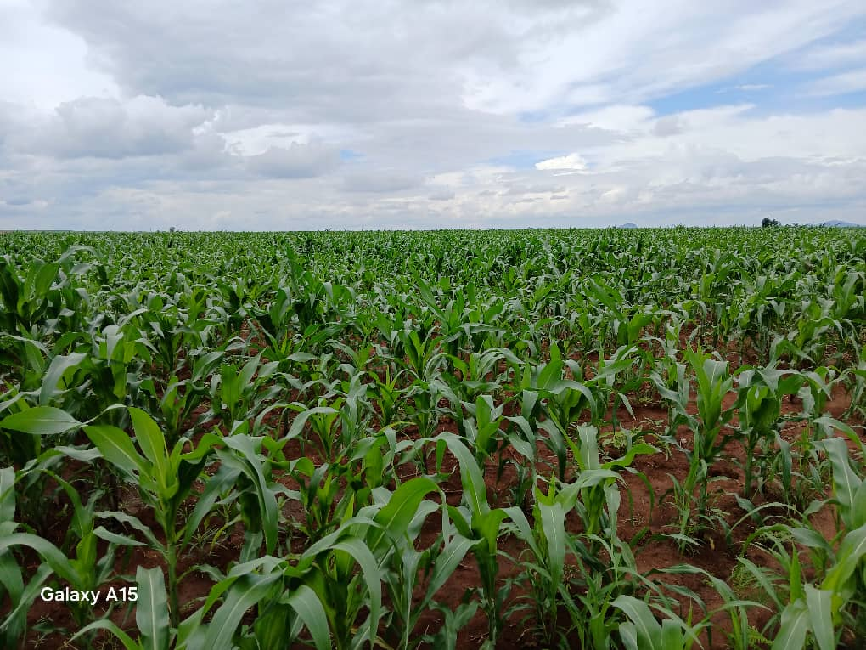

*Fig 2 shows Maize applied with Mbeya organic fertilizer in Msitu EPA*

**Crop Residue Incorporation**

* A total of 1,241ha have been incorporated with crop residues during the month with the involvement of 3,754 farmers of which 1,911 are males and 1,843 are females, to date 30,319ha has been incorporated which involved 85,519 farmers of which 48,339 are males and 37,180 are females, out of an annual target of 20,000 ha with the involvement of 25,000 male farmers and 25,000 female farmers.

**Agro-forestry**

* 20 agroforestry nurseries have been established during the month with the involvement of 509 farmers of which 219 are males and 290 are females, to date 382 agroforestry nurseries have been established with the involvement of 13,851 farmers of which 7,093 are males and 6,758 are females out of an annual target of 40 nurseries with the involvement of 1,200male farmers and 1,200 female farmers.
* 70,872 agroforestry seedlings have been raised during the month with involvement of 1,245 farmers of which 552 are males and 693 are females. To date 483,437 seedlings have been raised with 7,924 farmers involved of which 4,085 are males and 3,839 are females out of annual target of 160,000 seedlings with involvement of 1,200 male farmers and 1,200 female farmers.

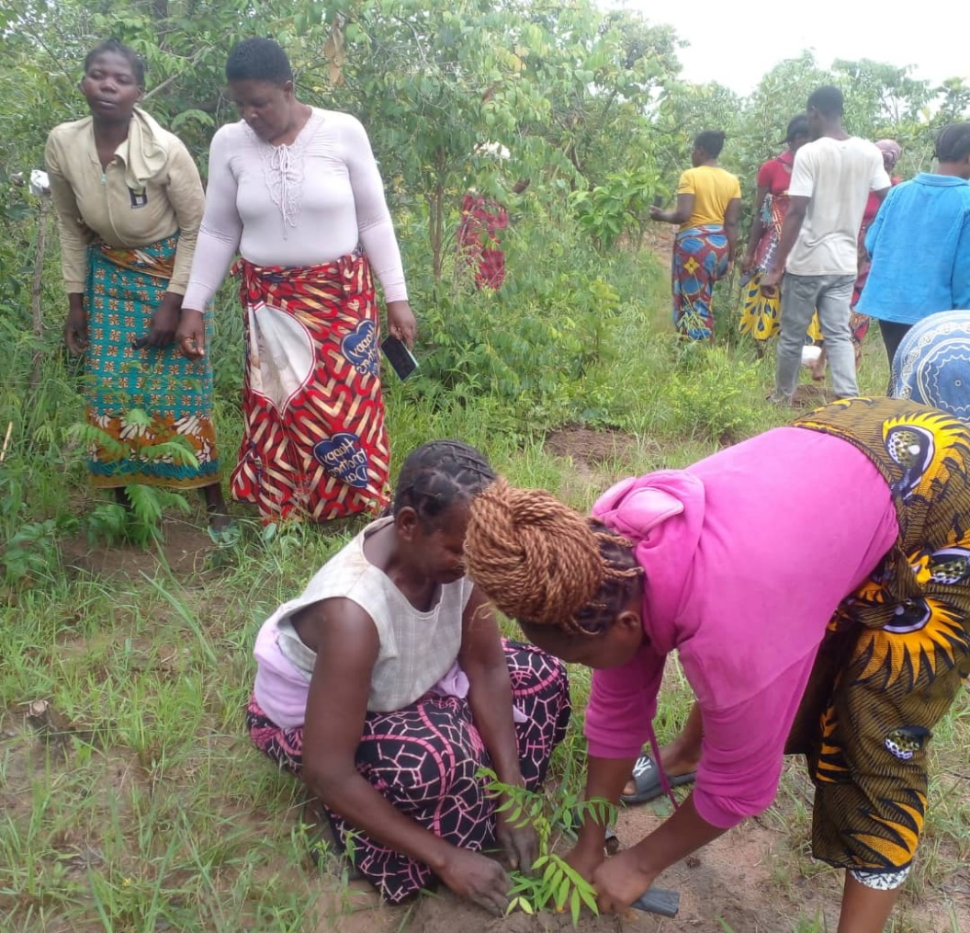

*Fig 3 shows AEDO demonstrating seedlings out planting in Mlonyeni EPA*

* 8,402 seedlings have been planted under homestead during the month and 92ha of land being covered with the involvement of 618 farmers of which 368 are male farmers and 250 are female farmers. To date 33,783 seedlings have been planted under homestead covering 154 ha of land with involvement of 1,704 farmers of which 955 are males and 749 are females out of annual target of 8 ha to be covered with 2,0150 seedlings with 100 male farmers and 100 female farmers.
* 37 ha of land has been covered under woodlot this month with 84,226 seedlings planted with 1,486 farmers being involved of which 728 are males and 758 are females. To date 45 ha have been covered with 105,226 seedlings planted with 1,695 farmers involved of which 840 are males and 855 are females out of annual target of 30ha and 75,00 seedlings to be planted with the involvement of 1200 male farmers and 1200 female farmers
* 26ha of land has been covered under mixed inter planting this month with the involvement of 483 farmers of which 291 are male farmers and 192 are female farmers. To date 322ha of land have been covered under mixed interplanting with 2,153 farmers involved of which 1,235 are males and 918 are females out of annual target of 30 ha with involvement of 38 male farmers and 38 female farmers.
* 9 ha of land has been in under-sowing this month in the district with the involvement of 64 farmers of which 42 are males and 22 are females. To date 20 ha of land have been in under-sowing with 162 farmers involved of which 102 are males and 60 are females.
* No any ha of land has been under improved fallows during this month. To date 2 ha of land is under improved fallows with 70 farmers involved of which 45 are males and 25 are females.
* No any ha of land has been covered under Dispersed Systematic Inter-planting during this month. To date 1 ha of land is covered under dispersed systematic inter-planting with 11 farmers involved of which 7 are males and 4 are females out of annual target of 30 ha with the involvement of 300 farmers of which 150 are males and 150 are females.

**Rain Water Harvesting Technologies**

* No any infiltration pond has been constructed as rain water harvesting technology during the month. To date 10 infiltration ponds have been constructed with 25 farmers of which 19 are males and 6 are female out of annual target of 20 ponds to be constructed with 50 male farmers and 50 female farmers.
* 40swales of 4,000m long have been constructed during the month involving 645 farmers of which 355 are males and 290 are females. To date 1,110swales of 124,811m long have been constructed involving a total of 6,264 farmers of which 3,648 are male farmers and 2,616 female farmers out of annual target of 8swales of 1,500m long with 100 male farmers and 100 female farmers.
* 228 infiltration/soak pits have been constructed have been constructed during the month with the involvement 180 farmers, of which 89 are males and 91 are females. To date 2,335 infiltration/soak pits have been constructed involving 1,611 farmers of which 983 are male farmers and 628 are female farmers out of annual target of 200 pits with involvement of 50 male farmers and 50 female farmers.

**Conservation Farming**

* A total of 506ha were under conservation agriculture during the month, with the involvement of 1,246 farmers of which 774 are males and 472 are females, total to date is 13,568ha have been covered with the involvement of 34,429 farmers of which 20,352 are males and 14,077 are females, out of the annual target of 806 ha with the involvement of 2016 farmers of which 1008 are males and 1008 females.
* A total of 273 ha of land have been managed under reduced tillage during the month with the involvement of 744 farmers of which 511 are males and 233 are females. To date 1,937 ha of land is under reduced tillage with 5,153 farmers involved of which 3,443 are male farmers and 1,710 female farmers out of annual target of 35 ha to be covered with 44 farmers from each gender.
* A total of 8 ha land has been covered under pit planting during the month with 164 farmers being involved of which 97 are male farmers and 67 are female farmers. To date 27ha of land has been covered under pit planting with 741 farmers involved of which 464 are male farmers and 277 are female farmers.
* A total of 526 ha of land have been covered with mulching materials in the district during the month with 1,141 farmers involved of which 759 are male farmers and 655 are female farmers. To date 4,465ha has been covered with mulching with 11,418 farmers being involved of which 7,475 are male farmers and 3,943 are female farmers out of annual target of 34 ha and 43 farmers from each gender.
* A total of 293ha of land has been covered up with cover crop during the month with the involvement of 741 farmers of 422 are male farmers and 319 are female farmers. To date 1,961 ha have been covered up with cover crop with 5,223 farmers involved of which 3,297 are male farmers and 1,926 are female farmers out of the annual target of 10 ha of land to be covered with 13 farmers being involved from each gender.
* A total of 703ha of land have been under rotation in this month with involvement of 1,822 farmers of which 1,094 are male farmers and 728 are female farmers. To date 12,049ha of land have been under rotation with the involvement of 28,903 farmers of which 17,979 are male farmers and are 10,924 female farmers out of the annual target of 500 ha and 625 farmers from each gender involved.
* A total of 609ha of land is being managed under inter-cropping during the month which involves 2,227 farmers of which 1,223 are male farmers and 1,004 are female farmers. To date 3,899 ha of land have been managed under inter-cropping with 12,961 farmers being involved of which 7,626 are males and 5,335 are females out of annual target of 220 ha of land to be covered and 275 farmers from each gender to be involved.

**Staff And Farmer Training**

**Staff Training**

* training session of staffs have been conducted during the month with 11 staff members involved of which 7 are males and 4 is a female. To date 15 training sessions have been conducted with the involvement of 215 frontline staff of which 136 are males and 78 are females, out of an annual target of 8 training sessions involving 97 frontline staff of which 77 are males and 20 females.
* No staff field days have been conducted during the month. To date 3 staff members have been participating of which 1 was a male and 2 were females.
* 1 staff study tour has been conducted during the month involving 3 staff members of which 1 was a male and 2 were females.

**Farmer Training**

* A total of 46 Farmer training sessions have been conducted during the month on rain water harvesting practices, conservation farming, soil fertility improvement and soil and water conservation with the involvement of 800 farmers of which 419 were males and 381 were females, to date 414 training sessions have been conducted with the involvement of 28,283 farmers have been trained on various technologies of which 17,902 are males and 10,381 are females, out of an annual target of 165 sessions with the involvement of 4,950 farmers of which 2,475 are males and 2,475 females.

**Demonstration**

* A total of 32 demonstration sessions were conducted on various land conservation technologies during the month with the involvement of 677 farmers of which 351 are males and 326 are females, to date 415 demonstration sessions have been carried out with the involvement of 18,754 farmers of which 10,461 are males and 8,293 are females, out of an annual target of 165 demonstration sessions with the involvement of 4,950 farmers of which 2,475 are males and 2,475 females.

**Field Day**

* A total of 1 field days have been conducted during the month with 62 members participating of which 37 were males and 25 were females. To date 26 field days have been conducted which involved 3,705 farmers of which 2,107 are males and 1,598 are females, out of the annual target of 4 with the involvement of 220 participants of which 110 are males and 110 females.

**Study Tours**

* 1 study tour has been conducted in the district during the month with the involvement of 6 participants, 3 members from each gender. To date 3 study tours has been conducted with 57 participants taking place of which 31 are males and 26 are females out of annual target of 1 tour to be conducted with 34 participants involved and 17 people from each gender.

**Campaign/Awareness Meeting**

* A total of 2 campaign meetings have been conducted during the month on various land resource conservation technologies with the involvement of 784 farmers of which 316 are males and 468 are females, to date 237 campaign meetings has been conducted on various technologies with the involvement of 61,216 farmers of which 30,591 are males and 30,625 are females, out of an annual target of 56 campaigns with the expected attendance of 2,800 farmers of which 1,400 are males and 1,400 females.

**Environmental Conservation Club**

* No any club has been formed during the month in the district. To date 2 club has been formed with 240 participants where 124 are males and 116 are females out of the annual of 7 clubs to be formed with 210 participants, 105 from each gender.

**Sensitization Meetings On Environmental Conservation**

* A total of 3 sensitization meetings were conducted during the month with the involvement of 105 farmers of which 60 are males and 45 are females, to date 145 sensitization meetings have been conducted with the involvement of 33,450 farmers of which 16,235 are males and 17,215 are females out of an annual target of 42 meetings with the involvement of 2,100 farmers of which 1,050 are males and 1,050 females.

**Awareness On Environmental Issues**

* No awareness meeting has been conducted during the month out of the total annual target of 7 meetings with involvement of 210 farmers of which 105 are males and 105 females**.**

**Plans for the Month of February**

* Conducting field days
* Facilitate tree planting
* Conducting farmer trainings in Climate Smart Agriculture

**NGOS Supporting Land Resources Activities**

|  |  |  |  |  |  |
| --- | --- | --- | --- | --- | --- |
| **NAME OF NGO** | **SERVICES PROVIDED/VALUE CHAINS BEING PROMOTED** | **LOCATION** | **FOCAL PERSON** | **CONTACTS** | **MOU WITH THE DC** |
| CICOD | Integrated catchment management | Zulu, kalulu, Mlonyeni | Amos Tizora | 0999855081 | Not yet |
| [amostizora@yahoo.co.uk](mailto:amostizora@yahoo.co.uk) |
| TOTAL LAND CARE | CSA | Kalulu, Mkanda,Mikundi and Chioshya | Richard Mseka | [Richard Mseka, rmseka@tlc.mw.org](mailto:rmseka@tlc.mw.org) | Available |
| AG CARE | CSA | Chioshya |  |  |  |
| FAO | CSA | Mkanda,Mikundi and kalulu | Stewart Chikomola | [Stewart.chikomola@fao.org,0999101714](mailto:Stewart.chikomola@fao.org,0999101714) | Available |
| PUMP AID | Integrated Catchment Management | Kalulu,Mikundi,Chioshya and Mlonyeni |  |  |  |

### **2.1.4 Crops Development highlights of achievements**

**2.1.4.1 Crop status**

Most of the rainfed crops were harvested while in irrigaion the crop ranged from emergency to maturity.

**2.1.4.2 Field Crops Achievements for the month of January**

* Conducted 1APES meeting/supervision against planned 1
* Conducted 1 spot checking visit on proper procedures for selling AIP INPUTS against a target of 1.
* Faclitated 2024/25 AIP beneficiary NID confirmation through AIP Secreteriat ana achieved 1 document out of the plannes 1

**2.1.4.3 Horticulture production Achievements**

* Conducted 2 farmer trainings out of a target of 2 on orchard site management,

**2.1.4.4 Farm Mechanization Achievements**

* Activities are inactive in this section as now

**2.1.4.5 Crop protection Achievements**

* Conducted 1 fall army worm monitoring visits against planned 2 visits and advice was given to those fields where the pest was identified.
* Conducted 1 army worm monitoring visits against planned 2 visits and advice was given to those fields where the pest was identified. Kalulu reported infestation and the issue was reported to Kasungu ADD
* Distributed Benzo, pesticides for fall Army worm treatment to all the EPAs plus Likasi Cattle Ranch

**2.1.4.6 Crops Plans for January, 2025**

* Participate in backstopping AEDOs in APES
* Backstop PICSA Training
* Conduct general crop supervision
* Monitor Fall army damage in Maize fields across all the EPAs
* Compile crops fortnightly report.
  + 1. **Livestock Production**

**Objectives/Outputs**

* Production of Livestock improved.
* Availability of domestic livestock products improved.
* Animal diseases incidences reduced.
* Veterinary Public health services improved.
* Delivery of livestock programs improved.

**Strategies**

* Broadening livestock ownership
* Improvement of public health against zoonotic and food borne diseases.
* Reduction of disease incidences through promotion of treatments and vaccinations.
* Promotion of plunge dipping, spraying and pour on to control external parasites
* Deworming as one way of controlling endo and parasites.

**2.1.5.1 Livestock Highlights for the month of January, 2025**

**Staffing Position**

|  |  |  |  |
| --- | --- | --- | --- |
| **POST** | **ESTABLISHED POSTS** | **NO. OF ESTABLISHMENT POST** | **POSTS FILLED** |
| AHLDO | I(CTO/PO) | 1 | 0 |
| Internee |  | 0 | 0 |
| SAVO | J(SAVO) | 0 | 1 |
| AVO | K(AVO) | 9 | 5 |
| AHSA | P(AHSA) | 9 | 17 |

*Table 1: Staffing levels for Mchinji December, 2024*

* 1. **Livestock Condition**

Most livestock classes were in good condition due to availability of feed in form of crop residues, natural pasture and madeya preserved by farmers and water for drinking.

**1.3 Dog Bites**

The district recorded 51 dog bite cases and 2 were not recommended for anti-rabies vaccine.

On **10/01/25** six people were bitten by a stray dog at Chimwankango trading centre in Mkanda EPA. The office collaborated with Mchinji District through Mkanda heath centre and EPA.HSA and AVO collected head sample and sent to district office which submitted to CVL.

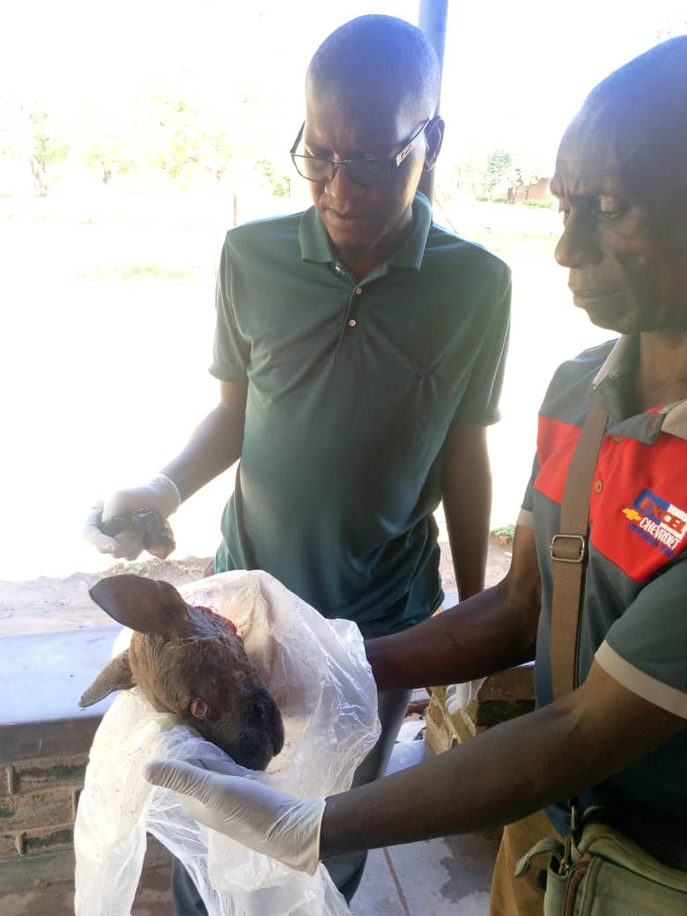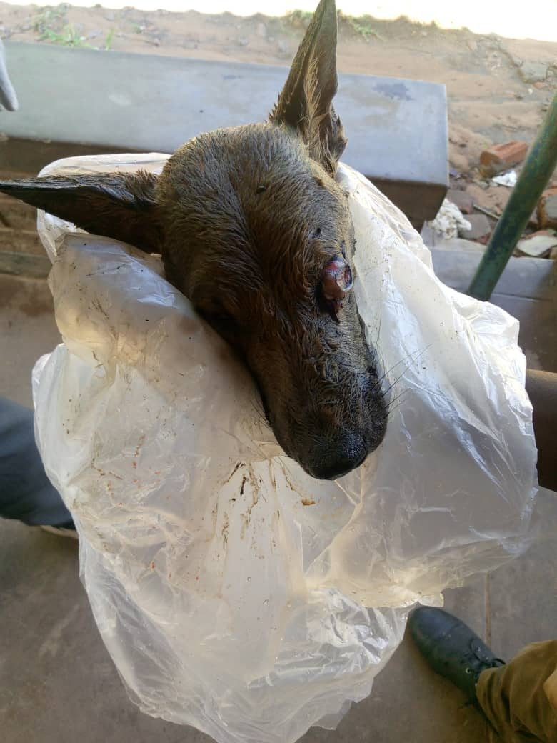

*Figure 1; AVO and HSA Collecting Head Sample for SubmissioN.10/01/25*

**Action Taken**

* Immediate Follow Ups and Reporting
* Used one health approach to collect sample
* Submitted sample to CVL which came out positive
* Sensitized the community and planning for ring vaccination

**1.4 Veterinary Interventions**

Frontline staff conducted treatments, vaccinations, de-worming, castrations and parasite control in animals during the month.

**1.5 Rabies Vaccination**

The district received 1000 vials of Rabsin from DAHLD and total of 10000 dogs are expected to be vaccinated in this year across the district. A total of **353** dogs were vaccinated in January, 2025 and a total of **8271** of dogs have been vaccinated to date.

1.**6 Lumpy Skin Disease Sensitization Campaign**

Mchinji district through AVO received a report that some animals were manifesting signs of LSD in Mkanda EPA. The cases were reported on 20th November 2024 and AVO went to verify on 24th November 2024.DAHLDO reported and filled the emergency reporting form immediately and started sensitisation.

In subsequent weeks the disease was reported by Mikundi and Mlonyeni EPA where a team was sent for verification and sensitisation. The district facilitated resource mobilisation and started vaccinations on 31 December, 2024 and managed to vaccinate **2211** cattle.

**Findings**

|  |  |  |  |
| --- | --- | --- | --- |
| **EPA** | **Number Of Kholas** | **Number Affected(sick)** | **Villages** |
| Mlonyeni | 31 | 52 | Molisiyo,Ndawembe,Sitolo, |
| Chisenga,Shangeni,Chapanzi,Tikoliwe,Menyani |
| Tsumba 1,Kadzani |
| Mkanda | 47 | 53 | Menyani,Guzani,Chiwaya,Kazgozgo |
| Mikundi | 21 | 35 | Sigaleta,Lezani,Nsula,Daniel,Timoti |
| **TOTAL** | **99** | **140** |  |

*Table 2: EPAs Affected by LSD in Mchinji, 2024-2025*

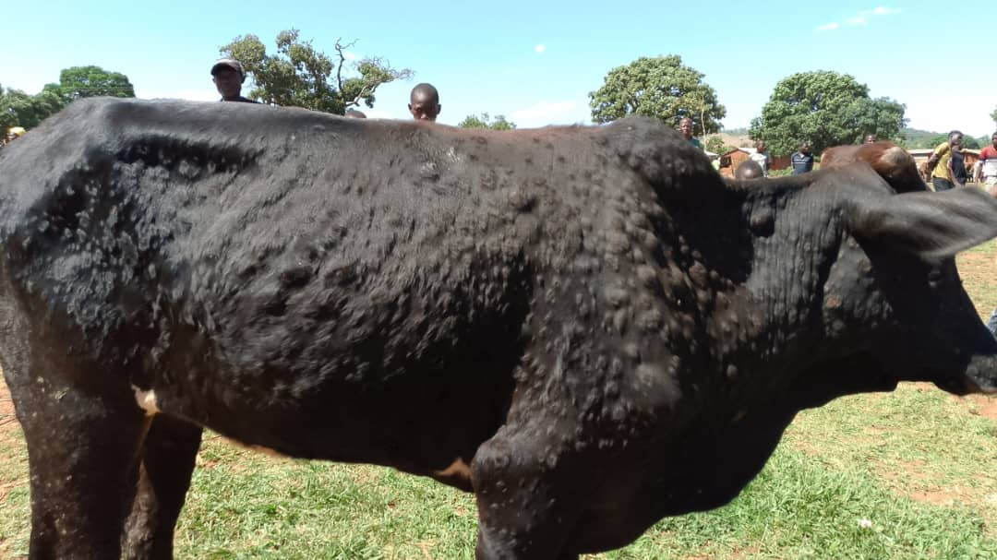

*Figure 1: one of the suspected LSD case in Mlonyeni EPA,Ndawambe vg,2024*

**ACTIONS TAKEN BY DISTRICT**

* Reported to authorities
* Immediately started sensitisations across the district
* Convinced farmers to mobilise resources
* Facilitated procurement of vaccines and vaccinated cattle
* Intensified active surveillance

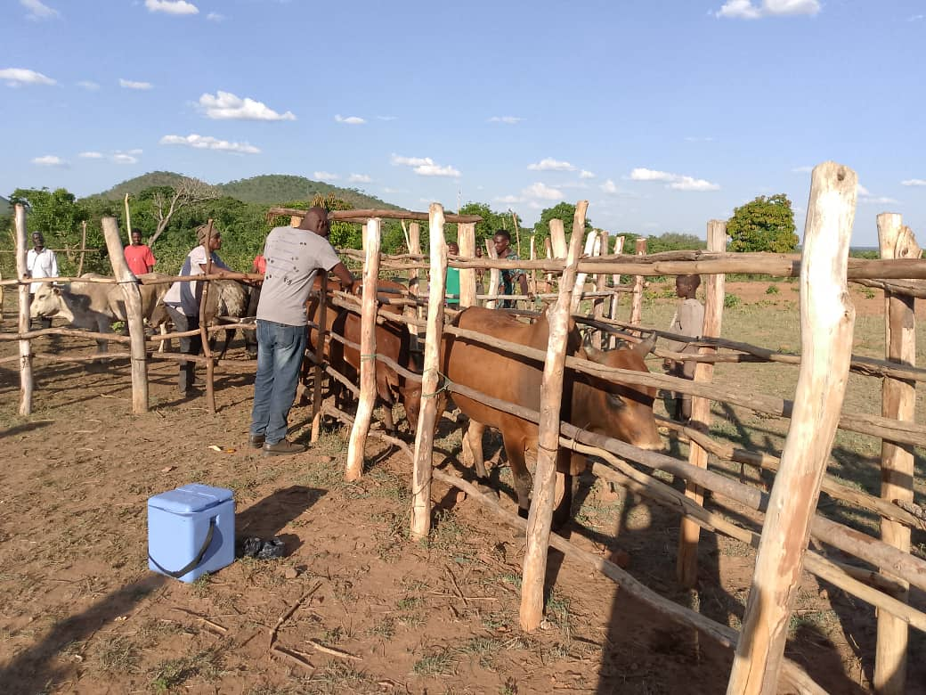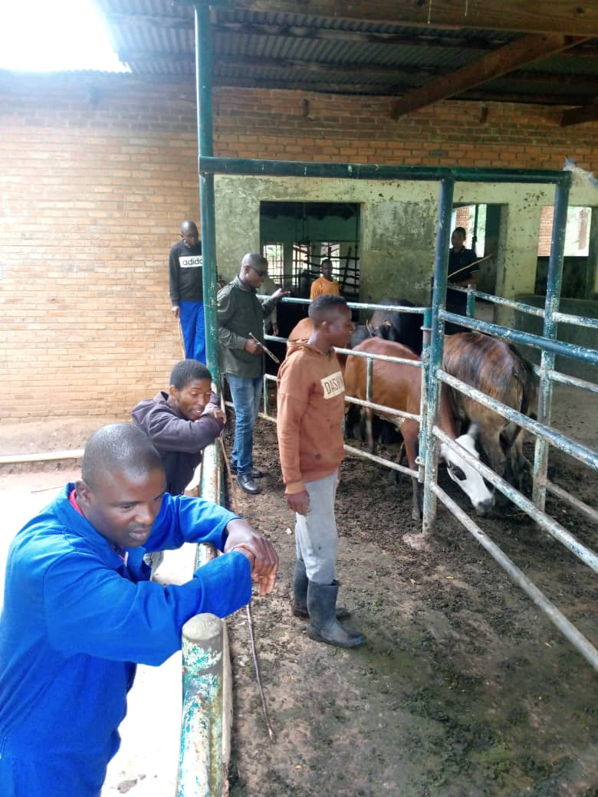

*Figure 2: LSD vaccination in Mlonyeni and Gada Farm in Mchinji*

**Table 2: LSD Cattle vaccination in Mchinji, 2024-25**

|  |  |
| --- | --- |
| **Centre** | **No.Vaccinated** |
| **MLONYENI EPA** |  |
| Ndawambe | 586 |
| Molosiyo | 237 |
| Chisenga | 243 |
| Tsumba1 | 212 |
| Kachebere | 85 |
| Gada(Mkanda) | 182 |
| **TOTAL** | **1545** |
| **KALULU EPA** |  |
| TCG Farm | 231 |
| Goshen Farm | 241 |
| Sagawa Farm | 89 |
| Chimunthu Farm | 35 |
| Mphatso Farm | 55 |
| Hasrood Farm | 15 |
| **TOTAL** | **666** |
| **TOTAL CATTLE VACCINATED** | 2211 |

**Plans For The Month of January**

* Conduct treatments and livestock vaccinations including rabies vaccinations
* Facilitate Mbingwa cattle market
* Continue monitoring various diseases in all the EPAs
* Facilitate pass on programs
* Conduct sensitisation meetings on the revival of plunge dipping in non-operational dip tanks
* Conduct meat inspection

### **3.0 Challenges**

* Fall army worm in newly planted irrigation sites
* Under staffing.
* Limited resources for servicing of motor vehicles and motor cycless resulting into poor performance of the programme
* Failure on safeguards compliance by some institutions or projects.

### **4.0 Recommendation**

* To Continue monitoring fall army worm and other pests and diseases
* Vacant posts to be filled.
* More awareness exercise need to be organized towards community, citizen role in waste management and disposal.
* Need for intensifying field supervisions and interact with field officers and stakeholders in Agriculture matters
* Create communication systems to cover the gap of reporting lines.

### **5.0 Conclusion**

The Agriculture Sector is geared to make all efforts towards making sure that agriculture has sound and sustainable management activities However activities need to be funded according to the Cash Flow and need more support from Council and stakeholders need to achieve the desired course. Staff and farmers need to be incentivised so that they continue working hard in provision of services.

**Compiled By:**

Abraham Mhlanga

Chief Agriculture Officer

P.O. Box 7, Mchinji

**Contacts**

Mobile: +265 991 452 891

Email: [abuhmhlanga@gmail.com](mailto:abuhmhlanga@gmail.com)

**Received By:**

Mr. Hastings Yotamu

**Director of Agriculture Services**